Bridgepoint Parts Catalog

Section XXV: Accumulator Parts Page 1

PP41-809119

Accumulator

Nitrogen Charged

PP42-809029

Diaphragm

Hypro Pulsation Dampener

PP42-809030

Baffle

Hypro Pulsation Dampener

PP42-809275

Bladder - Accumulator

PP42-809274

Valve Assembly - Accumulator

PP42-809028

Valve Assembly

Hypro Pulsation Dampener

PP42-809272

Top – Accumulator

Pre 1996
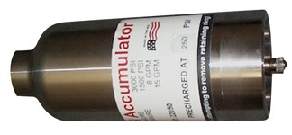
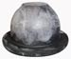

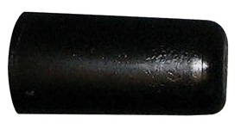
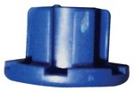

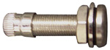
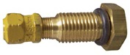

To choose the correct replacement Top for your Accumulator, you have to check the manufacture date of the Accumulator. The manufacture date is noted by a two-letter code stamped on the base of the Accumulator. The first letter A-M is the month. The second letter N-T is the year. (I & Q are not used.)
“AT” would be January –1996
“MS” would be December – 1995
- Accumulators manufactured before January 1, 1996 use
PP42-809273
- Accumulators manufactured after January 1, 1996 use
PP42-809363

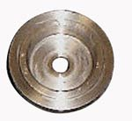

PP42-809363

Top - Accumulator

1996 & Newer

PP42-809273

Snap Ring - Accumulator Pre 1996

PCA6029

Pulsation Dampener – 1/2”MPT

Stainless Steel – Rechargeable

Prochem: Performer 805
(Prochem Part # 41-809159)

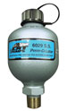
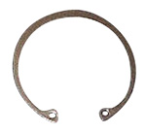

PP42-809362

Snap Ring – Accumulator

1996 & Newer

PP11-800368

Close Nipple 3/8”

Stainless Steel

PP11-800429

Hex Nipple 3/8” Stainless Steel
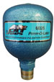
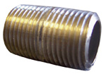

PCA6026

Pulsation Dampener – 1/2”MPT

Non – Rechargeable

Precharged at 250psi

Prochem: All truck mounts mfg. after November 2002.
(Prochem Part # 790106)

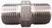

PP790113
Adapter 3/8” MPT x 1/2” FPT
Stainless Steel

Used for mounting PCA6026 on most Prochem Truckmounts, Saber & Lancer.
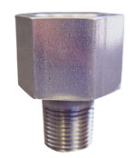

PP04092
Adapter 3/8” MPT x 1/2” FPT
10° Angle - Stainless Steel

Used for mounting PCA6026 on the Performer & Performer 405

